 |  | 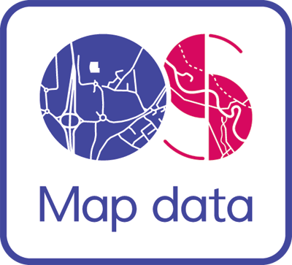
Sample Map
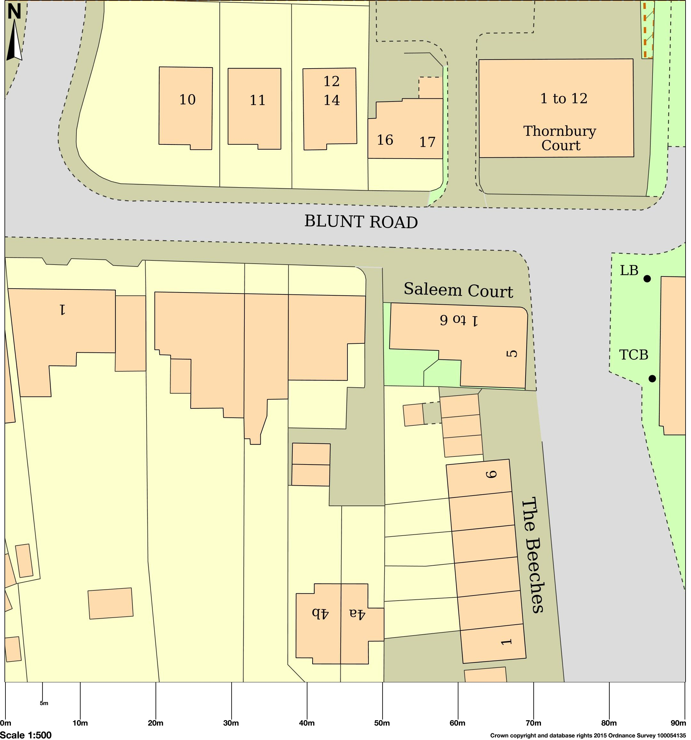
Map area bounded by: 532725.0,164326.0,532815.0,164416.0. Produced on 31 May 2015 from the OS National Geographic Database and incorporating surveyed revision available at this date. Reproduction in whole or part is prohibited without the prior permission of Ordnance Survey. © Crown copyright 2015. Supplied by UKPlanningMaps.com a licensed OS partner (100054135). Unique plan reference: b90b/36960/51561

