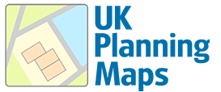 |  | 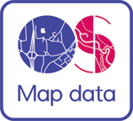
Sample Map
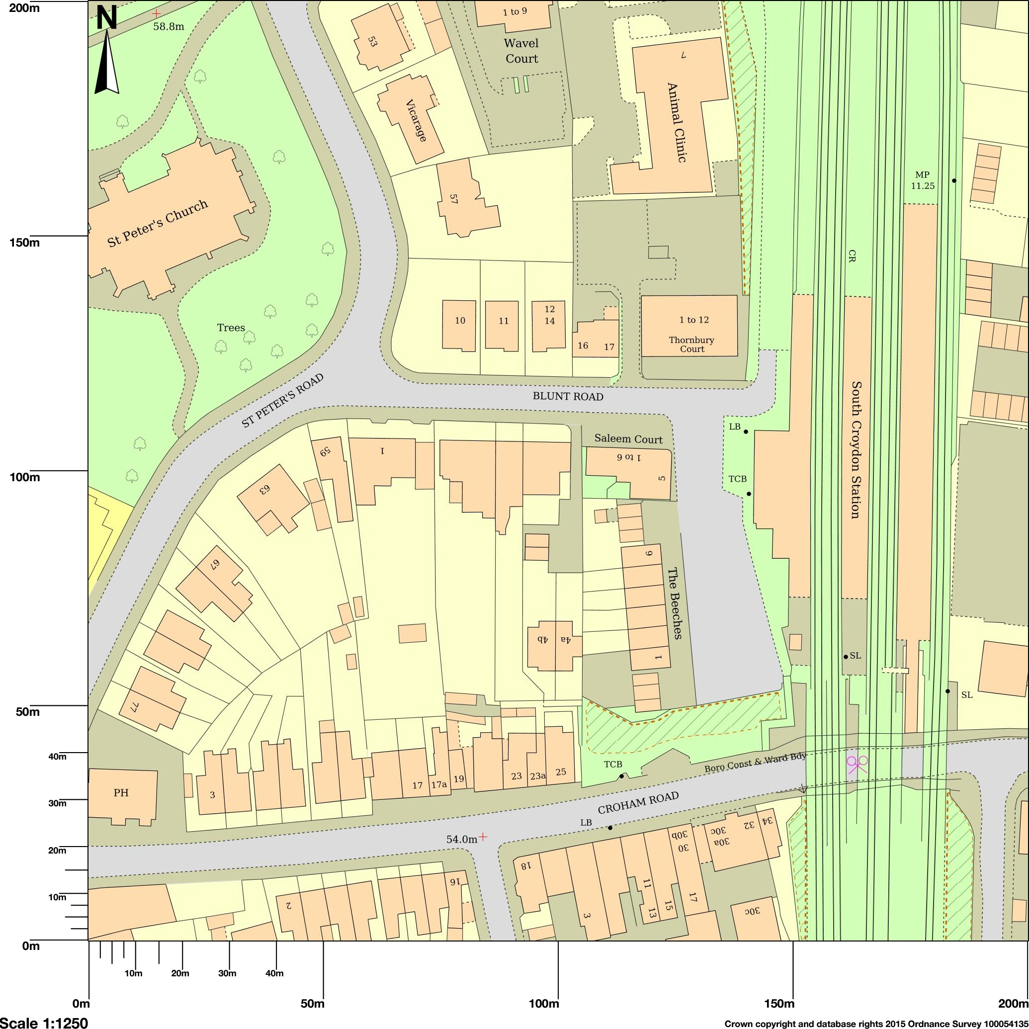
Map shows area bounded by: 532670.0,164271.0,532870.0,164471.0 at a scale of 1:1250. The representation of a road, track or path is no evidence of a right of way. The representation of features as lines is no evidence of a property boundary.
Produced on 31 May 2015 from the Ordnance Survey National Geographic Database and incorporating surveyed revision available at this date. Reproduction in whole or part is prohibited without the prior permission of Ordnance Survey. © Crown copyright 2015. Supplied by UKPlanningMaps.com a licensed Ordnance Survey partner (100054135). Unique plan reference: p4b/36960/51567. Ordnance Survey and the OS Symbol are registered trademarks of Ordnance Survey, the national mapping agency of Great Britain. UKPlanningMaps logo and other designs are Copyright © copla ltd 2015

