
Sample Site Plan, A3 1:200
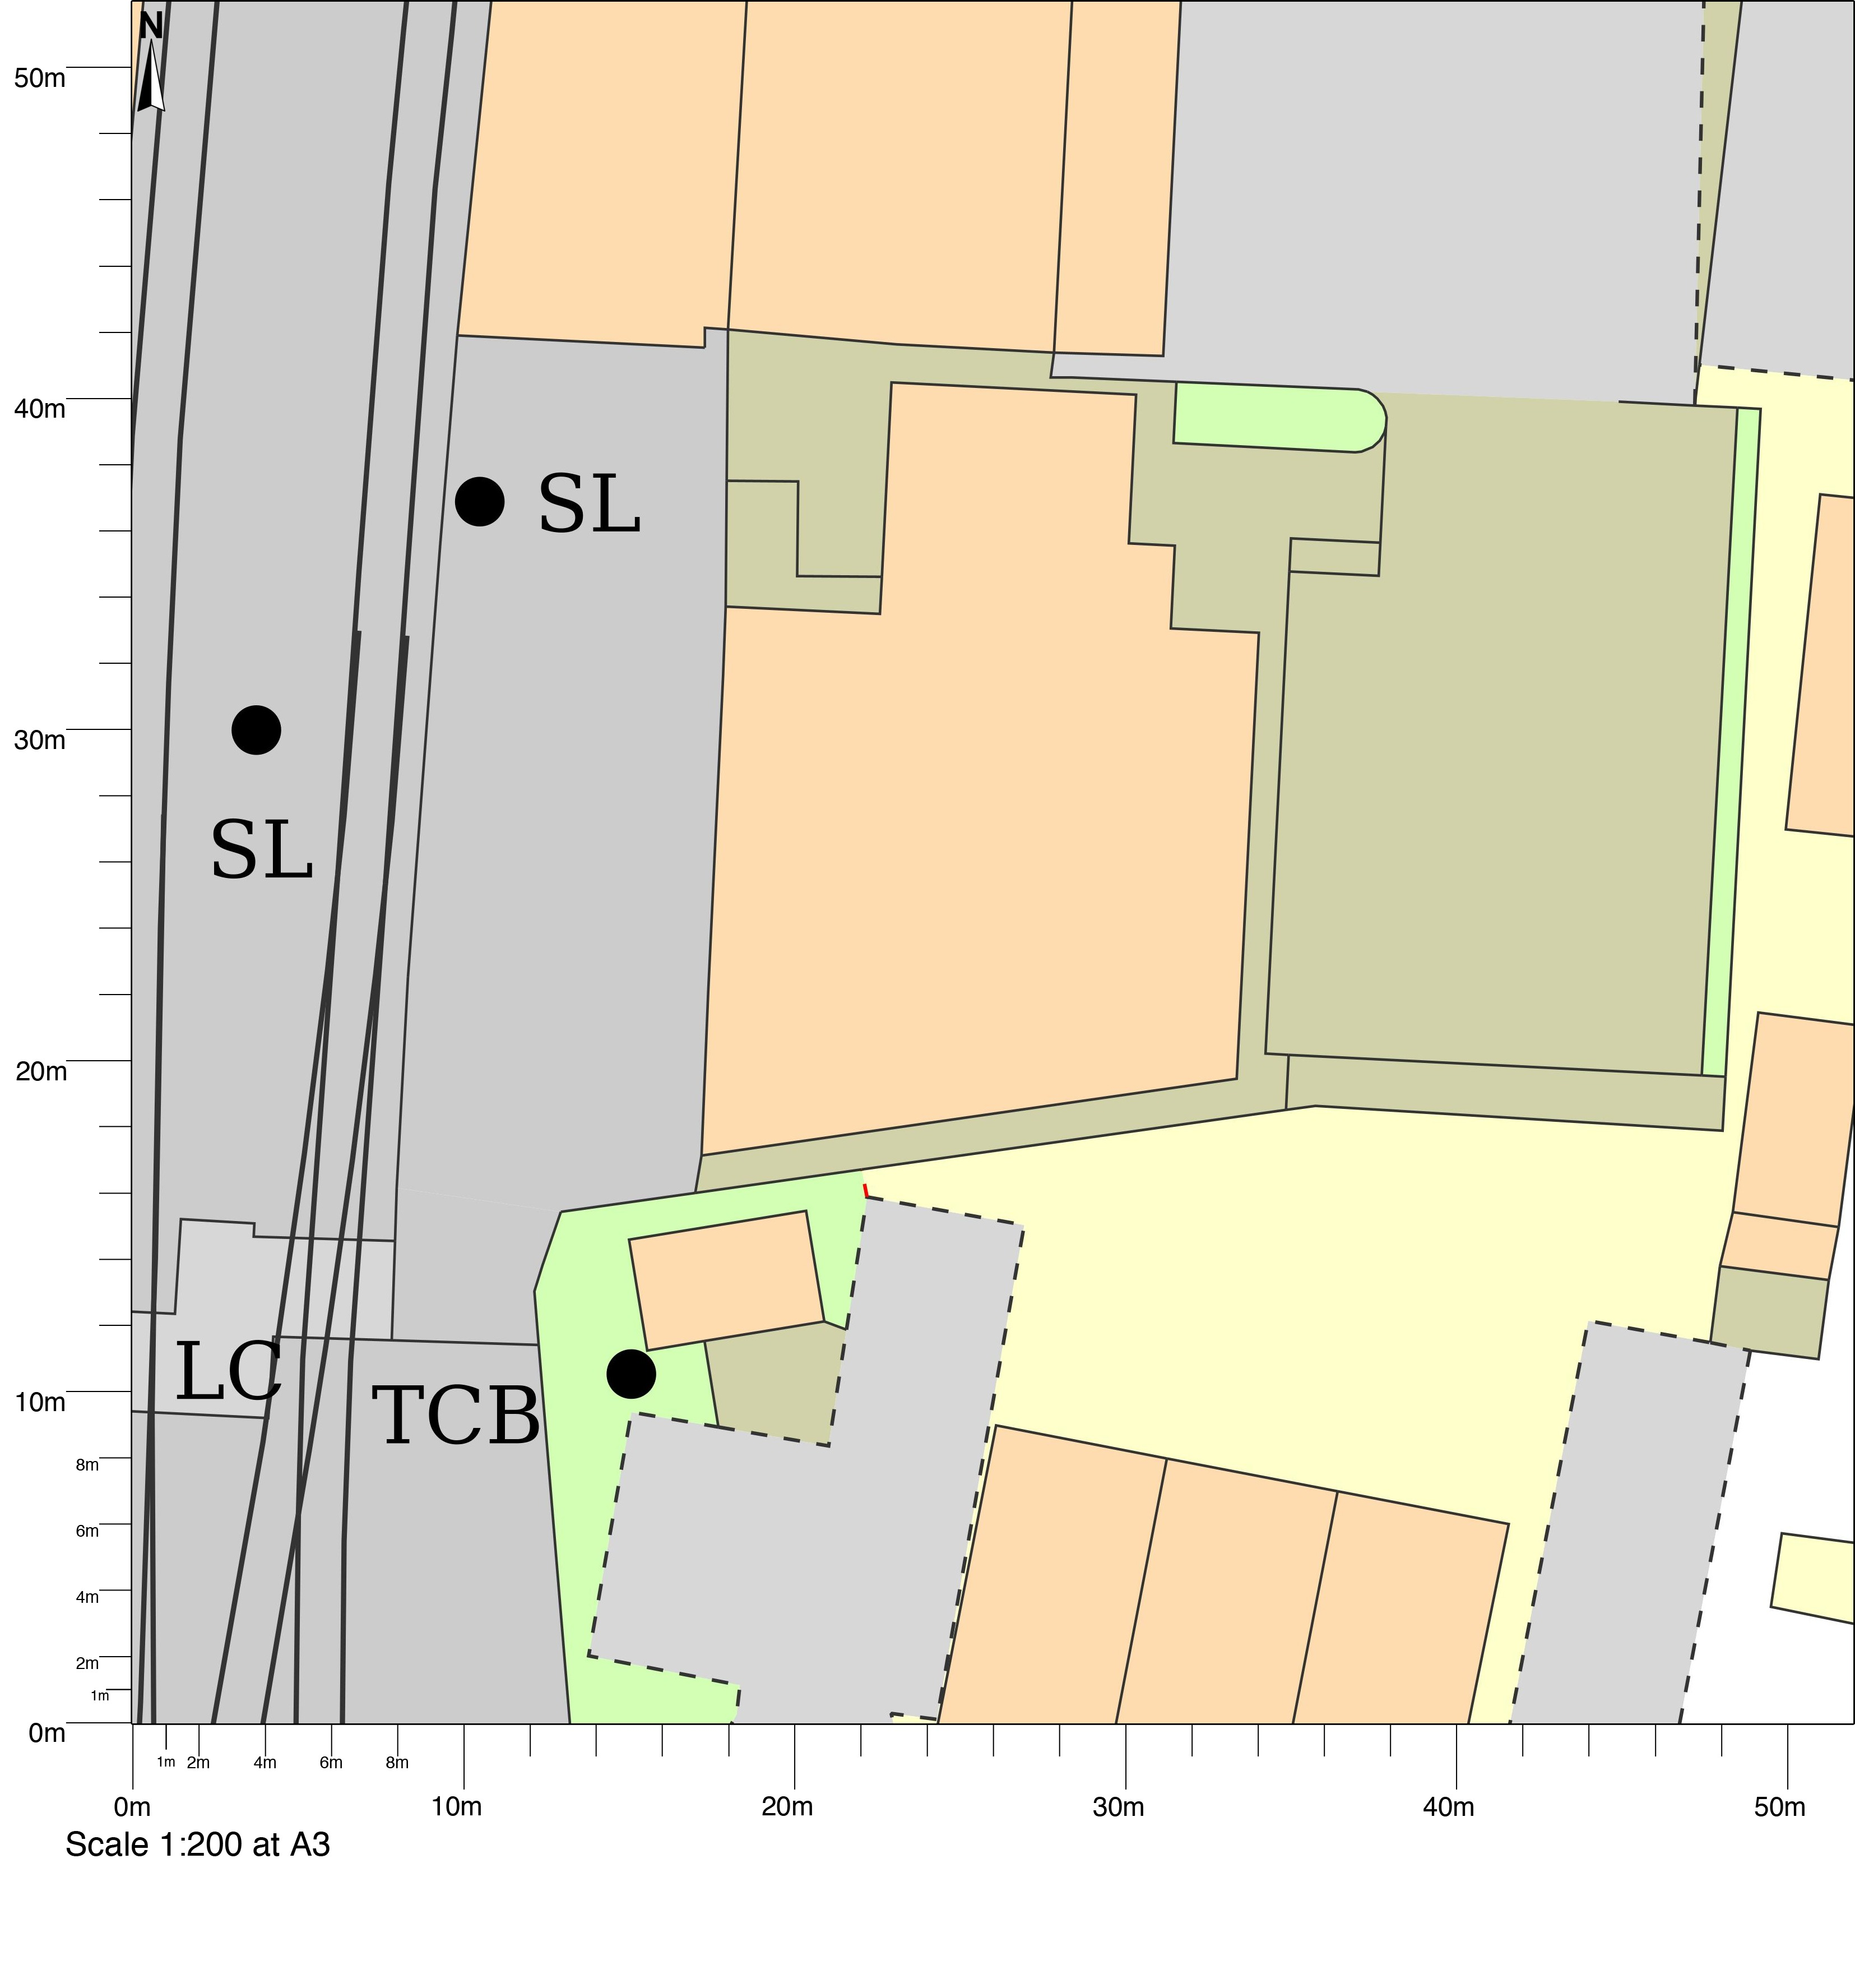
© Crown copyright and database rights 2023 OS 100054135.  Map area bounded by: 291146,93195 291198,93247. Produced on 24 November 2023 from the OS National Geographic Database. Supplied by UKPlanningMaps.com. Unique plan reference: a352e/uk/1007130/1358460 | 