
Sample Site Plan, A3 1:100
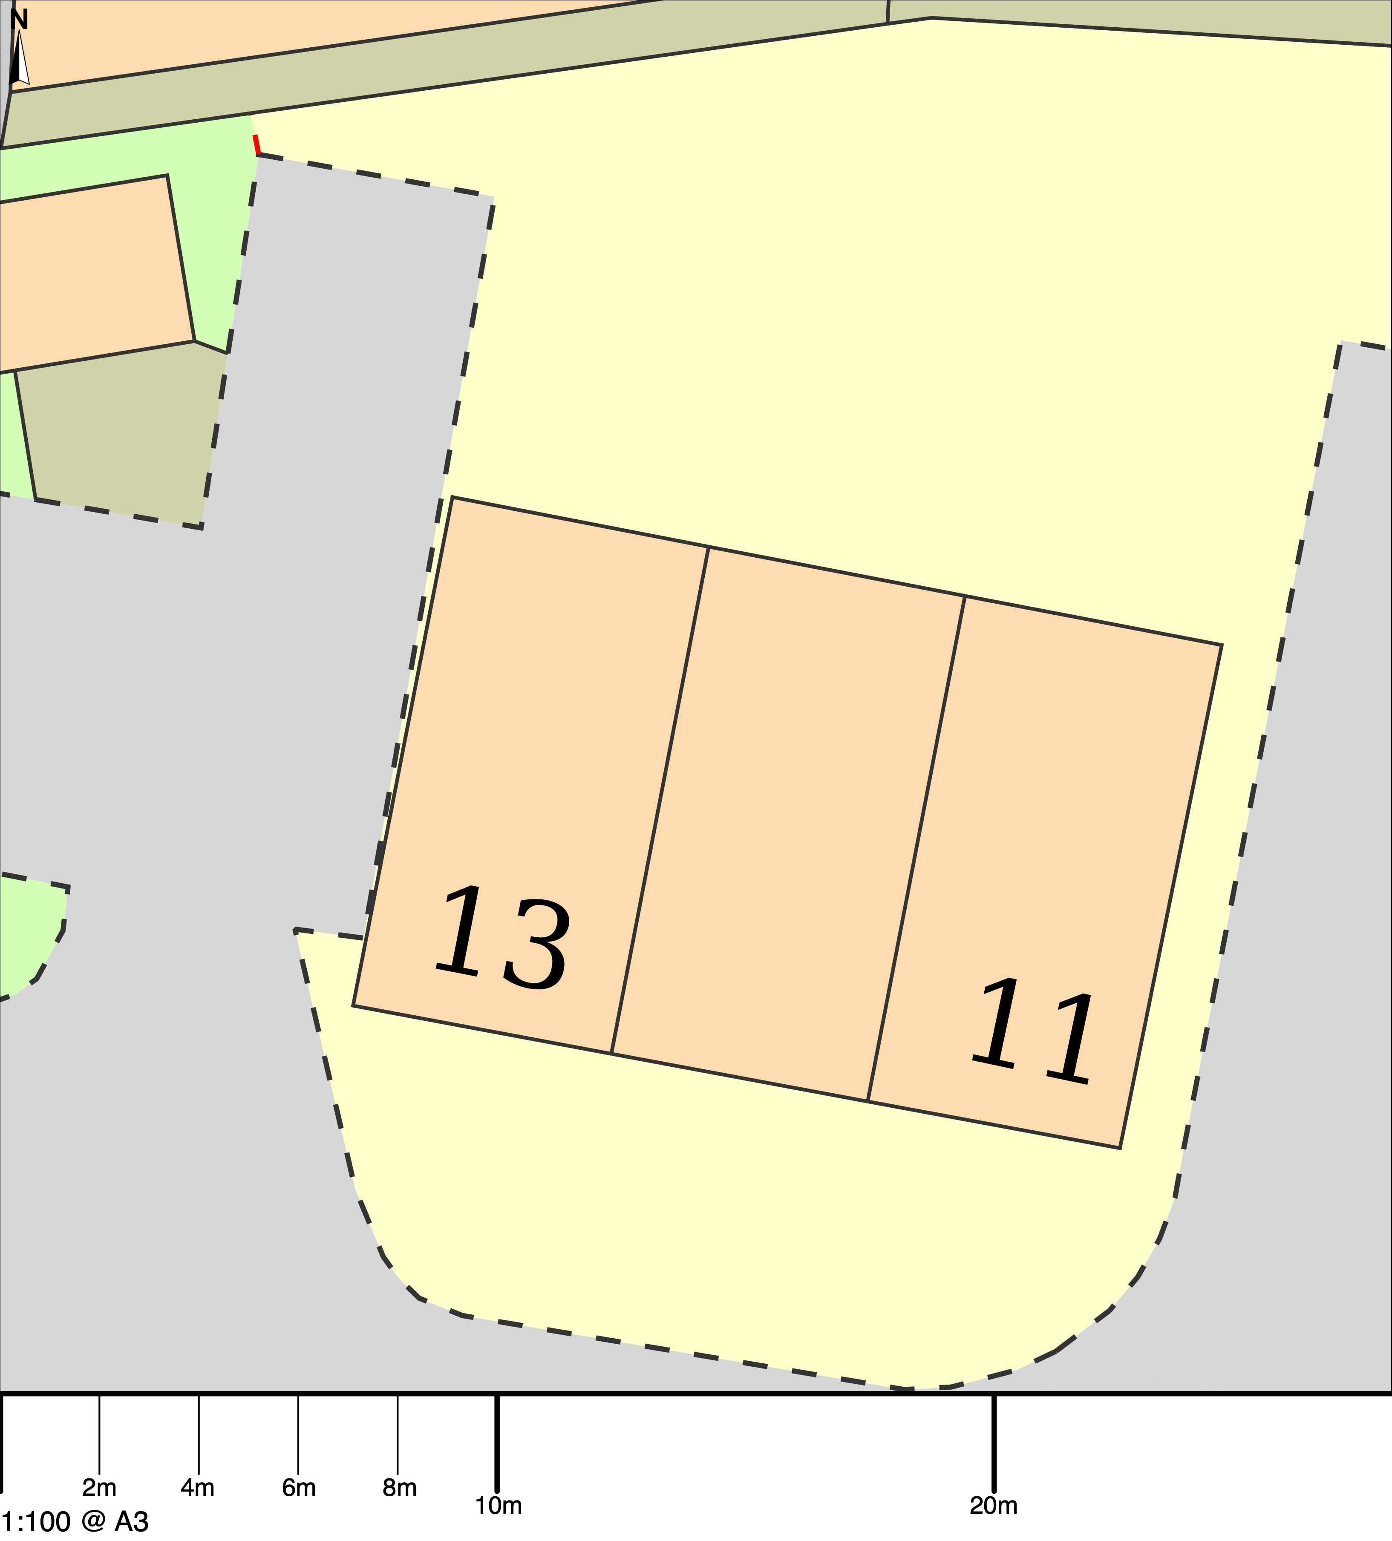
© Crown copyright and database rights 2023 OS 100054135.  Map area bounded by: 291163,93186 291191,93214. Produced on 24 November 2023 from the OS National Geographic Database. Supplied by UKPlanningMaps.com. Unique plan reference: a3100/uk/1007130/1358457 | 