
Sample Site Plan, A4 1:100
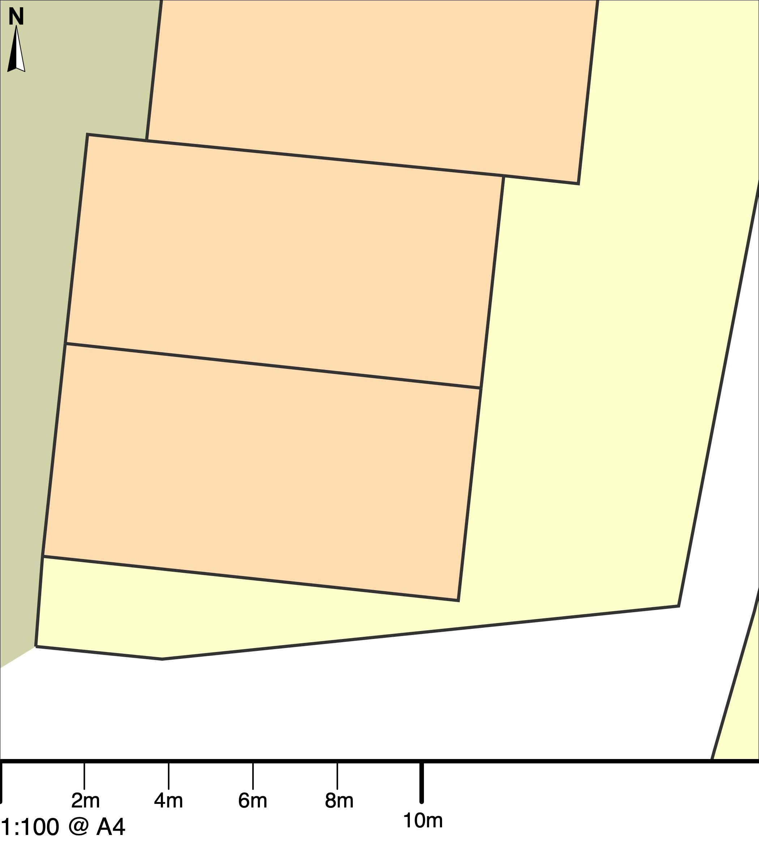
© Crown copyright and database rights 2023 OS 100054135.  Map area bounded by: 291211,93238 291229,93256. Produced on 24 November 2023 from the OS National Geographic Database. Supplied by UKPlanningMaps.com. Unique plan reference: a4100/uk/1007130/1358451 | 