
Sample Location Plan, A3, 9 Hectares, 1:1,250
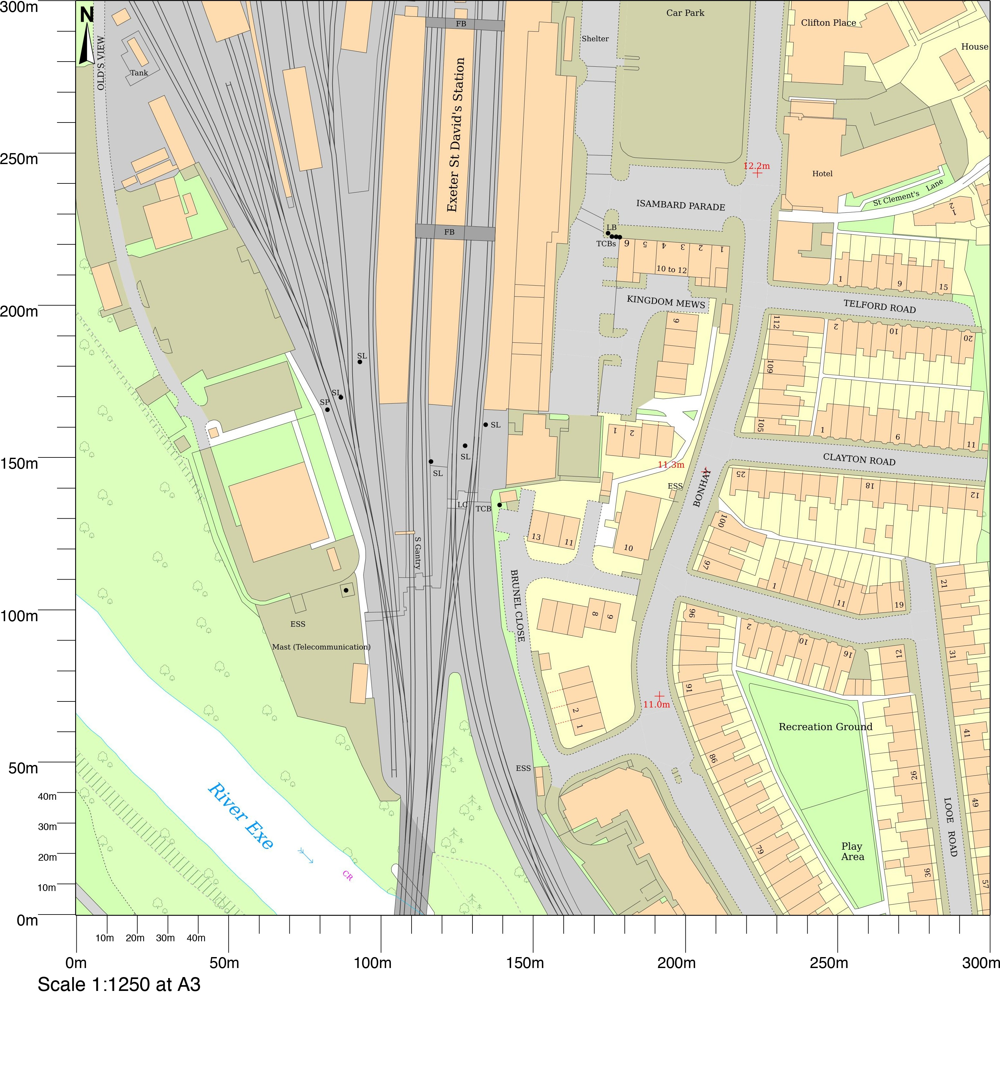
© Crown copyright and database rights 2023 OS 100054135.  Map area bounded by: 291022,93071 291322,93371. Produced on 24 November 2023 from the OS National Geographic Database. Supplied by UKPlanningMaps.com. Unique plan reference: a3300/uk/1007130/1358466 | 