
Sample Location Plan, A3, 36 Hectares, 1:2,500
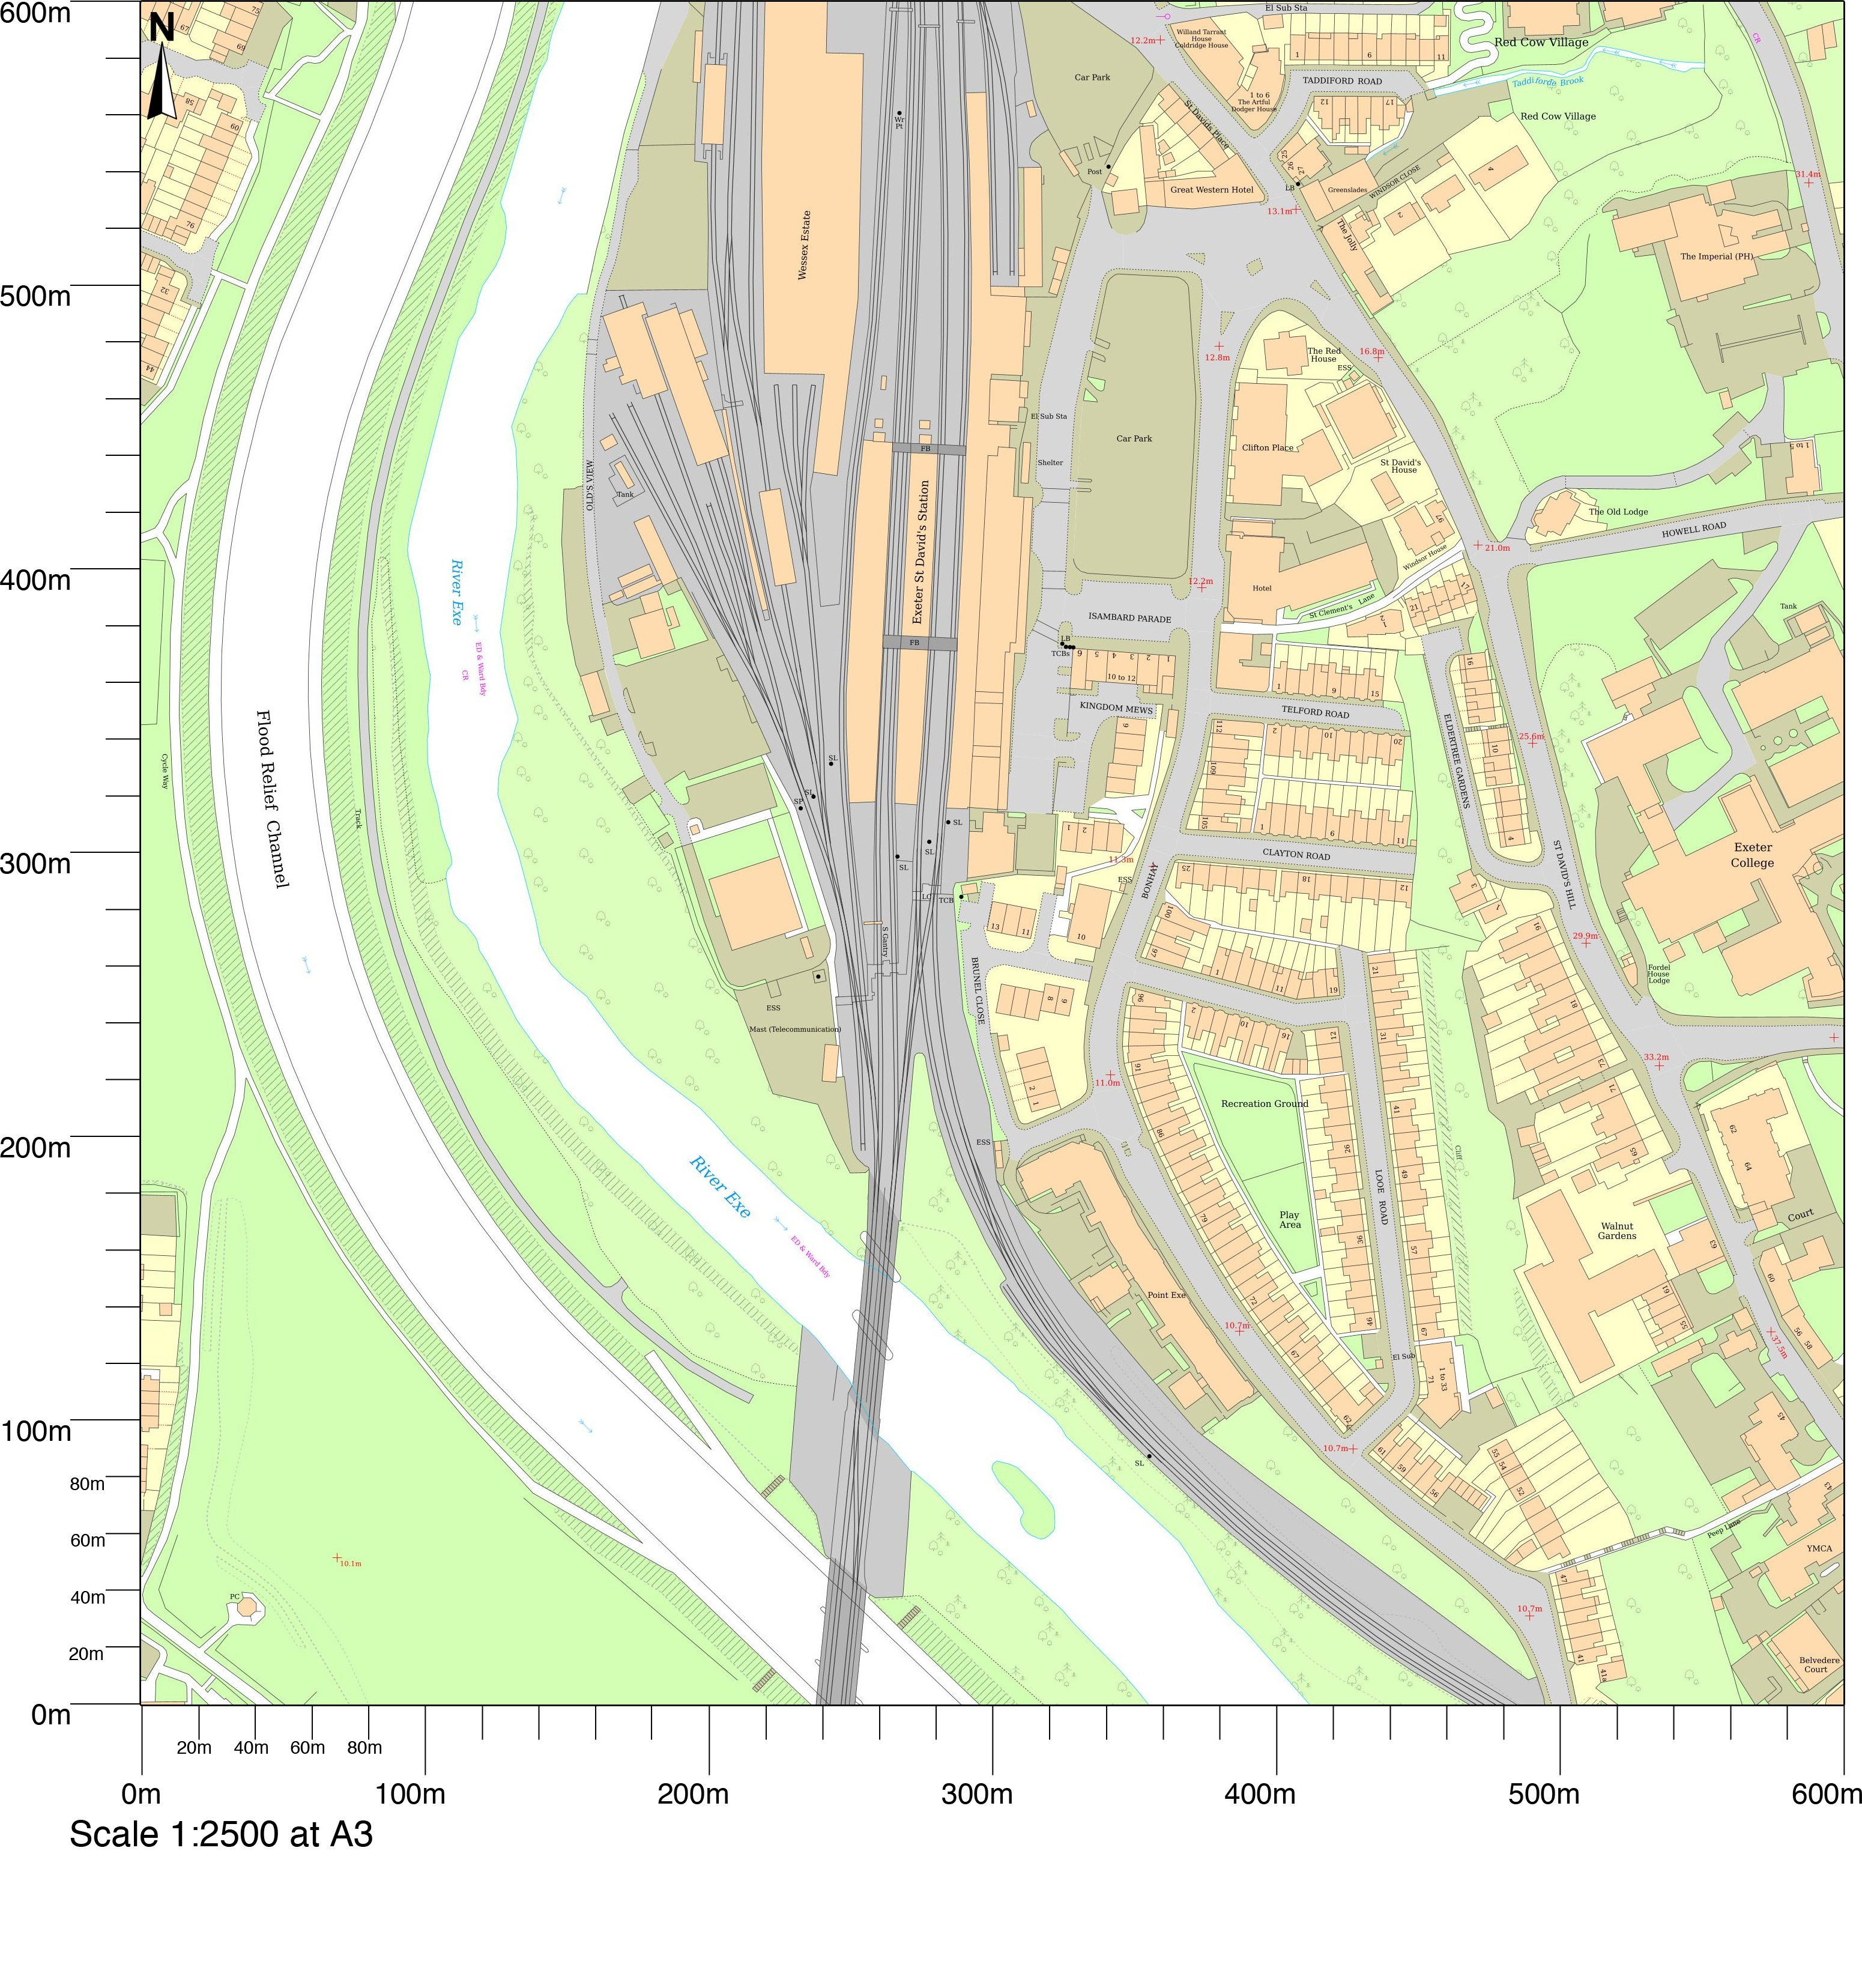
© Crown copyright and database rights 2023 OS 100054135.  Map area bounded by: 290872,92921 291472,93521. Produced on 24 November 2023 from the OS National Geographic Database. Supplied by UKPlanningMaps.com. Unique plan reference: a3600e/uk/1007130/1358469 | 